COVER PAGE
PHISHING EMAIL DETECTION & AWARENESS SYSTEM
Cyber Security Task 2 (2026)
Future Interns

Prepared By:
Bhavanidharan Sathiyaseelan

College
Paavai Engineering College

Department
B.E. Cyber Security

Table of content

S. No. | Contents | Page No.
1 | Cover Page | 1
2 | Table of Contents | 2
3 | Executive Summary | 3
4 | Introduction | 5
5 | Objectives | 6
6 | Tools Used | 7
7 | Phishing Indicators | 8
8 | Skills Demonstrated | 10
9 | Methodology | 11
10 | Email Analysis | 12
11 | Classification | 14
12 | Prevention & Awareness | 15
13 | Results | 17
14 | Conclusion | 18
15 | References | 19
16 | Appendix | 20

1. Executive Summary
Project Overview
The Phishing Email Detection & Awareness System is a cybersecurity project that identifies phishing emails by analyzing email headers and checking email authentication methods. It also helps users understand phishing attacks and learn how to recognize suspicious emails.
Objectives
- Detect phishing emails using email analysis.
- Analyze email headers to identify suspicious sender information.
- Verify email authenticity using SPF, DKIM, and DMARC.
- Identify phishing indicators such as fake domains and malicious links.
- Increase user awareness about phishing attacks and email security.
Tools Used
- Google Admin Toolbox – Analyzes email headers and verifies SPF, DKIM, and DMARC records.
- MXToolbox – Checks email authentication records and mail server information.
- Browser Inspection – Examines suspicious URLs, domains, and website security.
- Email Header Analysis – Reviews sender details, routing information, and email metadata.
Final Outcome
The project analyzed a sample phishing email and identified several phishing indicators, including failed SPF, DKIM, and DMARC authentication, suspicious sender domains, and unusual email header information. Based on the analysis, the email was classified as a phishing email. The project demonstrates how technical analysis and user awareness work together to improve email security and protect users from phishing attacks.

Tools Used
The project uses several free online tools to analyze suspicious emails, verify sender authenticity, and identify phishing attempts.
1. Google Admin Toolbox
Google Admin Toolbox is a free online tool used to analyze email headers and verify email authentication records.
Purpose:
- Analyze email headers.
- Verify SPF, DKIM, and DMARC records.
- Check sender authenticity.
- Review email routing information.
- Identify spoofed or suspicious emails.

2. MXToolbox
MXToolbox is an online email diagnostic tool used to verify email authentication and mail server information.
Purpose:
- Analyze email headers.
- Validate SPF records.
- Verify DKIM signatures.
- Check DMARC policies.
- Identify authentication failures and suspicious mail servers.

3. Browser Inspection
Browser Inspection is used to safely examine suspicious links and websites without interacting with harmful content.
Purpose:
- Check domain names for suspicious or fake websites.
- Verify URLs before opening them.
- Confirm HTTPS and website security.
- Inspect HTTP response headers.
- Identify redirects and phishing pages

2. Introduction

What is Phishing?
- Phishing is a social engineering attack used by cybercriminals to deceive users into revealing sensitive information.
- Attackers impersonate trusted organizations such as banks, government agencies, online services, or companies.
- Phishing attacks are commonly delivered through emails, SMS messages, phone calls, and fake websites.
- The main objective is to steal confidential information or install malicious software.
- Phishing exploits human trust and emotions rather than technical vulnerabilities.
- It is one of the most common and successful cyber threats worldwide.

Types of Phishing
- Email Phishing – Mass phishing emails sent to a large number of users.
- Spear Phishing – Personalized attacks targeting specific individuals or organizations.
- Whaling – Phishing attacks targeting senior executives and high-profile individuals.
- Clone Phishing – Legitimate emails are copied and modified with malicious links or attachments.
- Business Email Compromise (BEC) – Attackers impersonate business executives to request money or confidential information.
- Smishing – Phishing attacks conducted through SMS or text messages.
- Vishing – Voice phishing using phone calls to obtain sensitive information.

Why Phishing is Dangerous
- Steals usernames, passwords, and login credentials.
- Causes financial fraud through unauthorized transactions.
- Leads to identity theft and misuse of personal information.
- Installs malware, ransomware, spyware, and other malicious software.
- Results in data breaches and unauthorized access to confidential information.
- Causes business disruption, financial loss, and reputational damage.
- Exploits human error, making it difficult to prevent without awareness training.

Current Phishing Trends
- AI-generated phishing emails with highly convincing content.
- QR Code Phishing (Quishing) attacks.
- Cloud service impersonation (Microsoft 365, Google Workspace, Dropbox, etc.).
- Fake banking and online payment emails.
- Multi-factor authentication (MFA) bypass phishing attacks.
- Business Email Compromise (BEC) attacks targeting organizations.
- Mobile phishing through SMS and messaging applications.
- Fake delivery, shopping, and invoice scams.
3. Objectives
The primary objective of this project is to detect phishing emails by analyzing suspicious email characteristics and identifying common phishing indicators. The project aims to examine email headers, verify email authentication protocols such as SPF, DKIM, and DMARC, and inspect sender information, domains, and URLs to determine whether an email is legitimate or malicious. It also focuses on understanding phishing techniques, documenting the analysis results, and creating user awareness about email security. By using tools such as Google Admin Toolbox and MXToolbox, the project demonstrates practical phishing detection methods and promotes safe email practices to help prevent credential theft, financial fraud, malware infections, and other cyber threats.

4. Tools Used

Google Admin Toolbox
Google Admin Toolbox is an online email analysis tool used to examine email headers and verify email authentication mechanisms such as SPF, DKIM, and DMARC. It helps identify spoofed emails and investigate phishing attempts by analyzing sender information and email routing details.
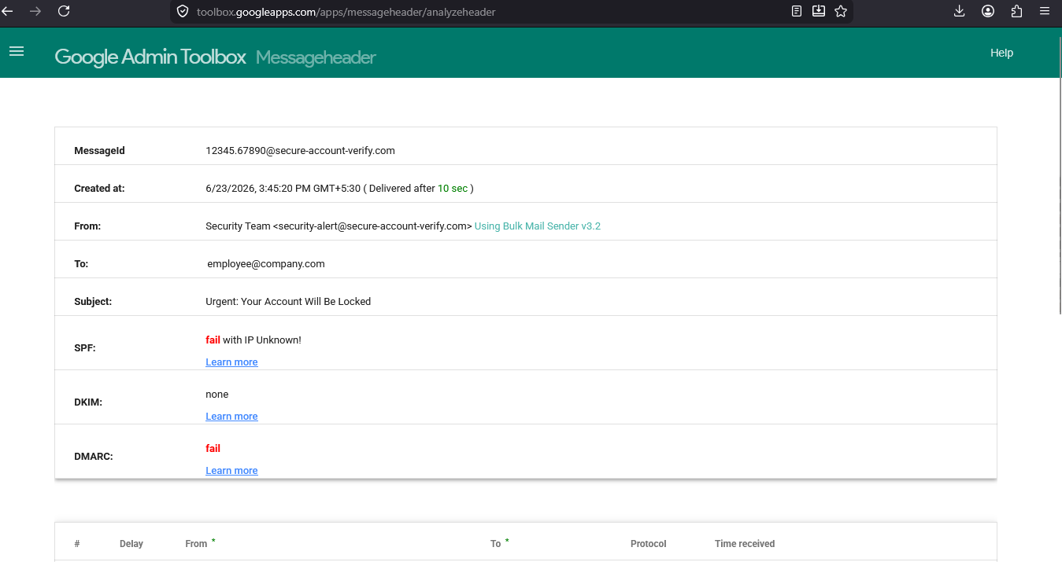

MXToolbox
MXToolbox is an email diagnostic and security analysis tool used to validate email authentication records, analyze mail server information, and inspect email headers. It assists in detecting phishing emails by identifying authentication failures and suspicious sender domains. 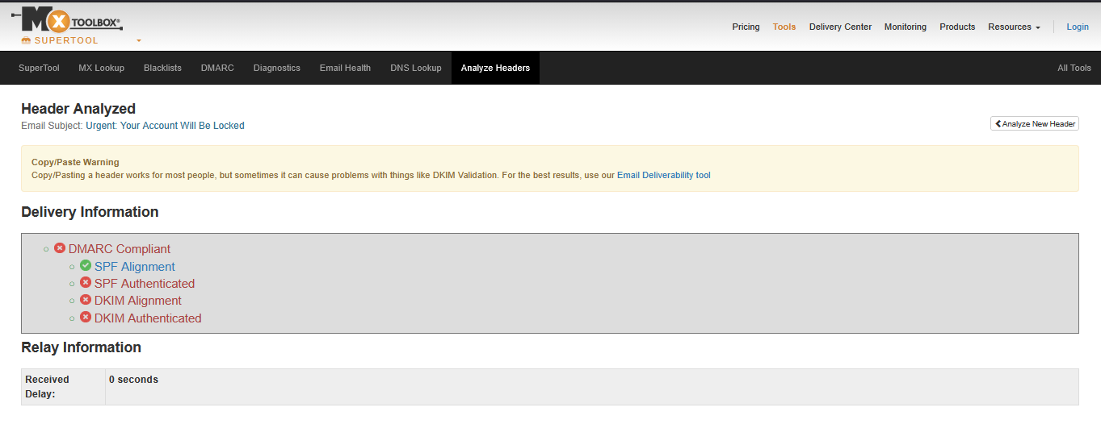

Microsoft Word / PDF
Microsoft Word was used to prepare and format the project documentation, while PDF was used to generate the final report for easy sharing, submission, and professional presentation.

GitHub
GitHub was used as a version control and project hosting platform to manage project files, documentation, screenshots, and reports. It provides a centralized repository for storing project resources and tracking updates throughout the project development process

6. Phishing Indicators
Phishing emails often contain several warning signs that help identify them as fraudulent. Recognizing these indicators is essential for preventing credential theft, malware infections, and financial fraud.
Fake Sender
Phishing emails often use fake or unfamiliar sender email addresses that appear similar to legitimate organizations. Attackers may slightly modify domain names to deceive recipients into believing the email is genuine.
Domain Spoofing
Cybercriminals create look-alike domains that closely resemble trusted company websites or email domains. These spoofed domains are designed to trick users into trusting the sender and interacting with the email.
Suspicious URLs
Phishing emails usually contain malicious or shortened URLs that redirect users to fake login pages or fraudulent websites. Users should always verify links before clicking and ensure they belong to the official domain.
Urgent Messages
Attackers frequently create a sense of urgency by using messages such as "Your account will be suspended" or "Immediate action required." This psychological tactic pressures users into acting without carefully verifying the email.
Unexpected Attachments
Many phishing emails include attachments disguised as invoices, reports, or official documents. Opening these attachments may install malware, ransomware, or spyware on the victim's device.
Grammar and Spelling Mistakes
Poor grammar, spelling errors, awkward sentence structure, and inconsistent formatting are common indicators of phishing emails. Although modern phishing attacks are becoming more sophisticated, many still contain language mistakes that reveal their fraudulent nature.
Request for Credentials
Legitimate organizations rarely ask users to provide passwords, banking details, OTPs, or other sensitive information through email. Any email requesting login credentials or confidential information should be treated as suspicious and verified through official communication channels.

7.Skills Demonstrated

Through the completion of the Phishing Email Detection & Awareness System project, the following technical and professional skills were demonstrated:

- Phishing Detection – Identified phishing emails by analyzing sender information, email content, and common phishing indicators.

- Email Threat Analysis – Performed email header analysis and verified email authentication protocols including SPF, DKIM, and DMARC to determine email legitimacy.

- Security Awareness – Applied cybersecurity best practices to recognize phishing attempts and developed user awareness guidelines for safe email usage.

- Risk Communication – Assessed the potential risks associated with phishing attacks, including credential theft, malware infection, financial fraud, and data breaches, and communicated the findings clearly.

- Professional Documentation – Prepared a well-structured cybersecurity project report with technical analysis, screenshots, findings, conclusions, references, and recommendations following professional documentation standards.

- Email Authentication Analysis – Interpreted authentication results from Google Admin Toolbox and MXToolbox to identify spoofed or unauthorized emails.

- Cybersecurity Investigation – Conducted systematic analysis of suspicious emails using industry-standard tools and documented the investigation process.

- Analytical and Problem-Solving Skills – Evaluated technical evidence, interpreted security findings, and classified emails based on authentication results and phishing indicators.

8.Methodology
The following methodology was followed to analyze and classify the phishing email:
Step 1: Collect Phishing Email Samples
A sample phishing email was collected for analysis. The email included the sender's address, subject, message content, and email headers required for investigation.
Step 2: Analyze Email Headers
The email header was examined to identify important fields such as From, Reply-To, Return-Path, Message-ID, and Received. This helped determine the origin of the email and identify any signs of spoofing or suspicious routing.
Step 3: Verify SPF, DKIM, and DMARC
The email was analyzed using Google Admin Toolbox and MXToolbox to verify the three major email authentication protocols:
- SPF (Sender Policy Framework)
- DKIM (DomainKeys Identified Mail)
- DMARC (Domain-based Message Authentication, Reporting, and Conformance)
The authentication results were used to determine whether the sender was authorized and whether the email had been digitally verified.
Step 4: Examine Sender, URLs, Attachments, and Domain Reputation
The sender's email address, embedded URLs, attachments, and domain reputation were inspected for phishing indicators. Suspicious domains, fake sender addresses, malicious links, and unexpected attachments were identified as potential security risks.
Step 5: Classify the Email
Based on the email header analysis, authentication results, phishing indicators, and security tool findings, the email was classified as either Legitimate or Phishing. In this project, the analyzed email failed multiple authentication checks and contained several phishing indicators; therefore, it was classified as a High-Risk Phishing Email.

9. Email Analysis
The collected email was analyzed using email header inspection and authentication verification to determine whether it was legitimate or a phishing attempt. The analysis focused on the sender's information, email authentication results, and common phishing indicators.

Header Analysis
The email header was examined to identify important fields such as From, Reply-To, Return-Path, Message-ID, and Received. The analysis revealed a suspicious sender domain, a mismatched Reply-To address, and the use of a bulk email sending application. These findings suggested that the email did not originate from a trusted source.

SPF, DKIM, and DMARC Results
The email authentication records were verified using Google Admin Toolbox and MXToolbox.
Authentication | Result
SPF | Failed
DKIM | None
DMARC | Failed
The failed SPF and DMARC authentication, along with the absence of a DKIM signature, indicated that the sender was not authorized to send emails on behalf of the claimed domain.
Sender Information
- Sender Name: Security Team
- Sender Email: security-alert@secure-account-verify.com
- Reply-To: support@verify-account-now.com
- Mail Client: Bulk Mail Sender v3.2
The sender's domain appeared suspicious and did not match a legitimate organization. The different Reply-To address further increased the likelihood of a phishing attempt.

Indicators of Phishing
The following phishing indicators were identified during the analysis:
- Suspicious sender email address.
- Domain spoofing using a fake domain.
- Mismatched Reply-To address.
- Urgent message requesting immediate account verification.
- Failed SPF authentication.
- Missing DKIM signature.
- Failed DMARC authentication.
- Use of bulk email sending software.
- Request to verify account credentials within a short time.

Risk Level
Risk Level: High
The email failed multiple authentication checks and contained several phishing characteristics, including spoofed sender information, authentication failures, and social engineering techniques. Based on these findings, the email was classified as a High-Risk Phishing Email, and users should avoid interacting with it, report it to the security team, and delete it immediately.

10.Classification
The analyzed email can be classified into one of the following categories based on the results of the email header analysis and authentication checks:
1. Safe
A Safe email passes email authentication checks (SPF, DKIM, and DMARC), originates from a trusted sender, contains no suspicious links or attachments, and does not exhibit phishing characteristics.
2. Suspicious
A Suspicious email shows one or more warning signs, such as an unfamiliar sender, unusual content, or partial authentication failures. These emails require additional verification before any action is taken.
3. Phishing
A Phishing email contains multiple indicators of a cyberattack, including fake sender information, spoofed domains, failed SPF, DKIM, or DMARC authentication, urgent or threatening messages, malicious links or attachments, and requests for sensitive information. Such emails should be reported immediately and deleted without interacting with them.
Final Classification
Classification: Phishing
Reason:
The analyzed email failed SPF and DMARC authentication, had no valid DKIM signature, used a suspicious sender domain, contained urgent language requesting account verification, and displayed multiple phishing indicators. Therefore, it is classified as a Phishing Email with a High Risk level.

11. Prevention & Awareness
Preventing phishing attacks requires both technical security measures and user awareness. By following safe email practices and recognizing common phishing indicators, users can significantly reduce the risk of becoming victims of cyberattacks.

Tips to Identify Phishing Emails
- Verify the sender's email address before trusting the message.
- Check the domain name for spelling mistakes or unusual characters.
- Be cautious of urgent or threatening messages that demand immediate action.
- Hover over links to verify the actual URL before clicking.
- Avoid opening unexpected attachments from unknown senders.
- Look for grammar, spelling, or formatting mistakes in the email.
- Never provide passwords, OTPs, or banking information through email.
- Check whether the email has passed SPF, DKIM, and DMARC authentication if possible.

Best Practices for Users
- Enable Multi-Factor Authentication (MFA) on all important accounts.
- Use strong, unique passwords and store them in a trusted password manager.
- Keep your operating system, browser, and antivirus software up to date.
- Use spam filters and email security solutions to block suspicious emails.
- Verify requests for sensitive information through official communication channels.
- Regularly participate in cybersecurity awareness and phishing training.
- Back up important data to protect against ransomware attacks.

What to Do if a Phishing Email is Received
- Do not click any links or buttons in the email.
- Do not open suspicious attachments.
- Do not reply to the sender or provide personal information.
- Verify the email by contacting the organization through its official website or customer support.
- Report the email to your organization's IT or cybersecurity team.
- Mark the email as Phishing or Spam in your email application.
- Delete the email after reporting it.
- If credentials have already been entered, immediately change the password, enable MFA, and notify the appropriate security team.

12. Results
The phishing email was analyzed using email header inspection, Google Admin Toolbox, and MXToolbox. The analysis identified multiple authentication failures and phishing indicators, confirming that the email was malicious.

Summary Table of Analyzed Email
Analysis Parameter | Result
Sender Verification | Failed
SPF Authentication | Failed
DKIM Authentication | None
DMARC Authentication | Failed
Header Analysis | Suspicious
Domain Reputation | Suspicious
Phishing Indicators | Multiple Detected
Risk Level | High
Final Classification | Phishing

Key Findings
- The sender's email address belonged to a suspicious domain.
- SPF authentication failed, indicating the sending server was not authorized.
- No valid DKIM signature was present to verify the email's authenticity.
- DMARC authentication failed, confirming that the email did not comply with the sender's authentication policy.
- The email contained urgent language intended to pressure the recipient into taking immediate action.
- The Reply-To address differed from the sender's address, indicating possible email spoofing.
- Multiple phishing indicators confirmed that the email was malicious.
- The email was classified as a High-Risk Phishing Email and should not be trusted or interacted with.

13. Conclusion
The Phishing Email Detection & Awareness System successfully analyzed a suspicious email using email header analysis and authentication mechanisms such as SPF, DKIM, and DMARC. The investigation identified multiple phishing indicators, including a suspicious sender domain, failed authentication checks, and the absence of a valid DKIM signature. Based on these findings, the email was classified as a High-Risk Phishing Email.
The project highlights the importance of email authentication in protecting users from phishing attacks. Protocols such as SPF, DKIM, and DMARC help verify the authenticity of email senders, prevent email spoofing, and improve the reliability of email communication. Organizations that implement these authentication mechanisms can significantly reduce the risk of phishing, fraud, and unauthorized email usage.
The project also emphasizes the importance of cybersecurity awareness. Users should always verify the sender's email address, inspect links before clicking, avoid opening unknown attachments, enable Multi-Factor Authentication (MFA), and report suspicious emails immediately. Combining strong email authentication with continuous cybersecurity awareness and safe email practices provides the most effective defense against phishing attacks and helps protect individuals and organizations from evolving cyber threats.

14. References
The following references were used to support the analysis and preparation of this project:
- Future Interns – Cyber Security Internship Resources and Project Guidelines.
https://futureinterns.com
- Google Admin Toolbox – Message Header Analyzer.
https://toolbox.googleapps.com/apps/messageheader/
- MXToolbox – Email Header Analyzer and Diagnostic Tools.
https://mxtoolbox.com
- Google Workspace Documentation – Email Authentication (SPF, DKIM, and DMARC).
https://support.google.com/a
- Microsoft Security – Email Security and Phishing Protection.
https://www.microsoft.com/security
- OWASP (Open Worldwide Application Security Project) – Security Awareness and Best Practices.
https://owasp.org
- RFC 7208 – Sender Policy Framework (SPF) for Authorizing Use of Domains in Email.
https://www.rfc-editor.org/rfc/rfc7208
- RFC 6376 – DomainKeys Identified Mail (DKIM) Signatures.
https://www.rfc-editor.org/rfc/rfc6376
- RFC 7489 – Domain-based Message Authentication, Reporting, and Conformance (DMARC).
https://www.rfc-editor.org/rfc/rfc7489

15.Appendix (Screenshots & Evidence)


Google Admin Toolbox.png



MX Toolbox.png
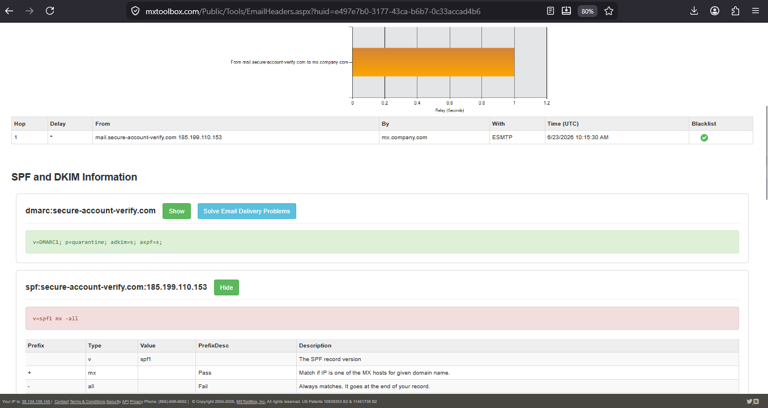
MX Toolbox 2.png

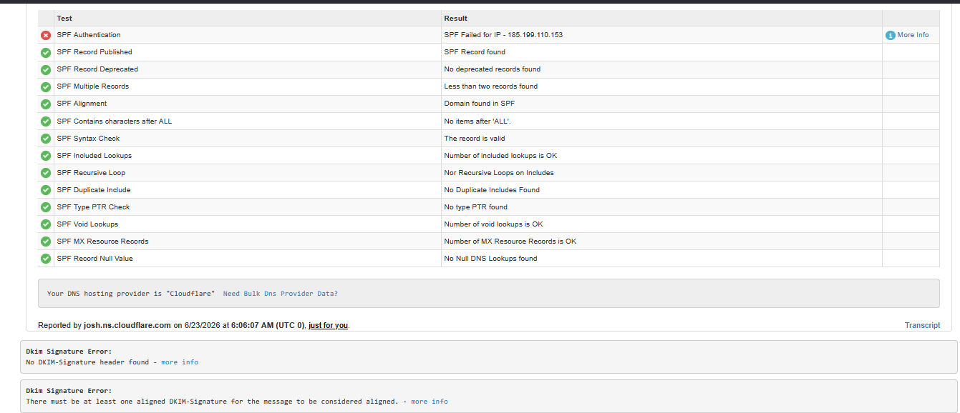
MX Toolbox 3.png
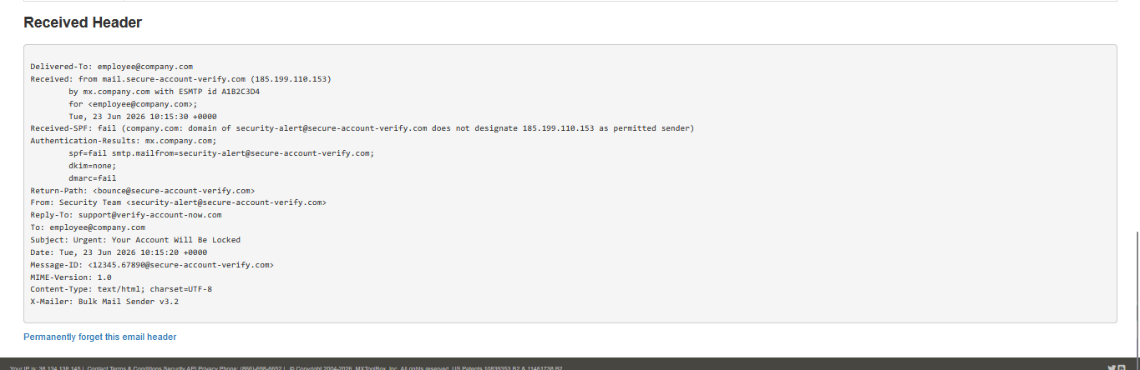 mx Toolbox 4.png
MX Toolsbox
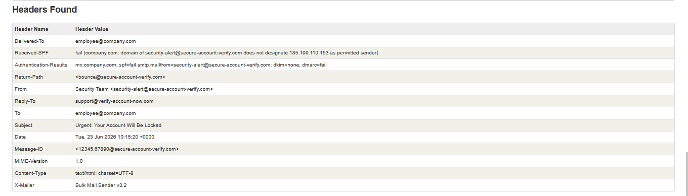
MX Toolsbox 5.png

